MCSL Final Project

Remote Control Timer Switch

0410001

Hong-Shuo Chen

1. Motivation

When I am at home, I always use Mechanical Timer as the picture below to control fans or lights. However, it is not convenient to use. We need to rotate and press down segments on the timer, and the time unit is fifteen minutes that I cannot choose any time I want to shut down my electrical appliances. Therefore, I want to design a remote control timer switch which can help me make my life more convenient.

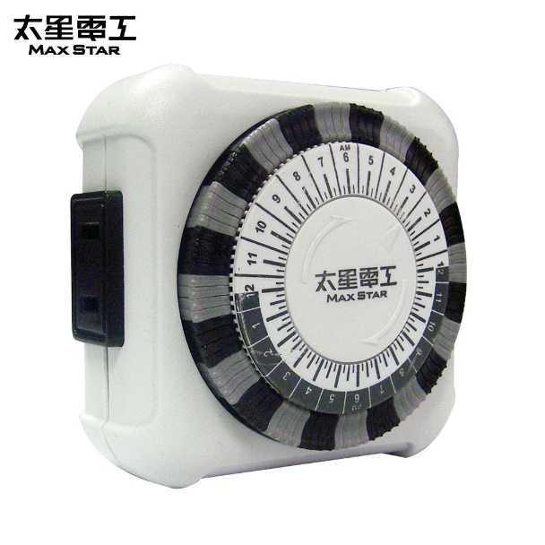

1. Function

* Able to use Smartphone to open or close electrical appliances whenever I want.
* Able to know the status of electrical appliances.
* Set a time that electrical appliances turn on or shut down.
* Able to count down from a specified time interval which is given from the smartphone and turn on or shut down after time is counted down.

1. Material and Equipment

* 4-Relay-DC5V-Module

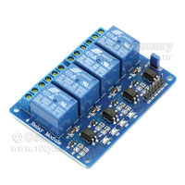

* ESP-12-ESP8266

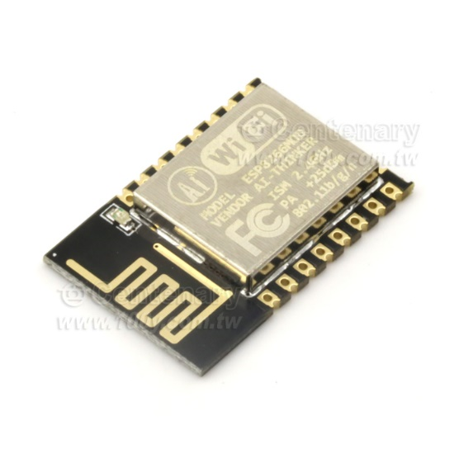

* Plug and Extension cord

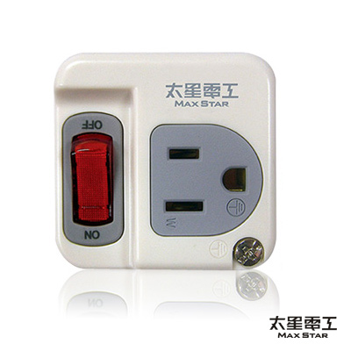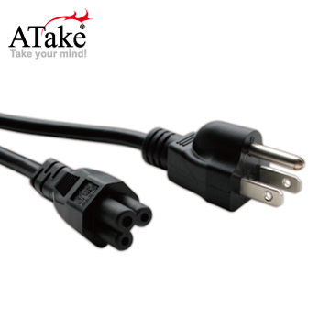

* Smartphone

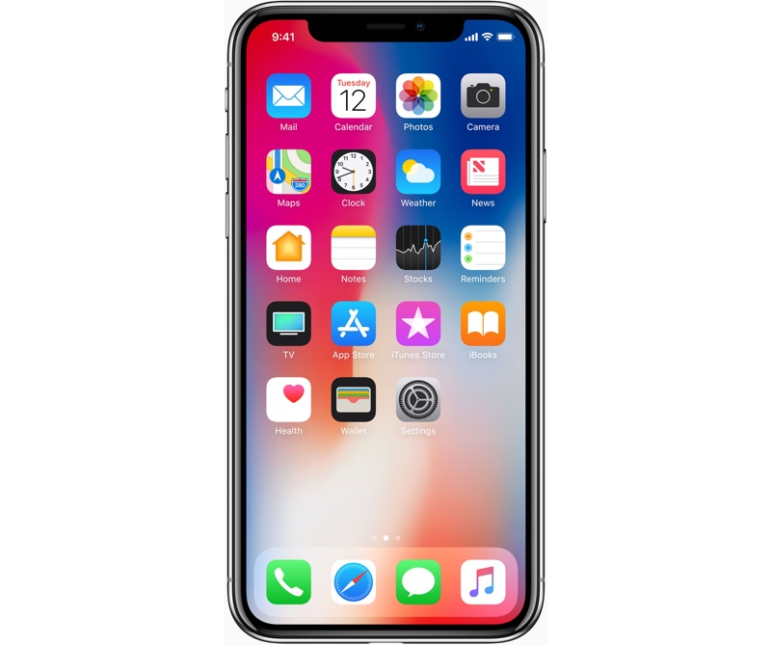

* Router

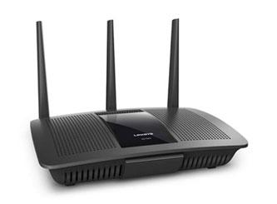

1. Product Architecture

